Software Requirements Specification

For

Smart Home System

Version 1.1 approved

Prepared by BSE20-43

Makerere University

16th December 2019

**REVISION HISTORY**

|  |  |  |  |
| --- | --- | --- | --- |
| **Name** | **Date** | **Reason For Changes** | **Version** |
| All | 13/11/2019 | Changes in product functions and software quality attributes | 1.1 |

**List of Figures**

Figure 1: Log in page of the Smart Home System

Figure 2: Interface page for choosing and controlling different lights

Figure 3: Interface page for choosing and controlling different doors

Figure 4: Interface page for choosing and controlling fans

Figure 5: Interface page for choosing and controlling TV

Figure 6: Use case diagram

Table of Contents

1. Introduction 1

1.1 Purpose 1

1.2 Document Conventions 2

1.3 Intended Audience and Reading Suggestions 2

1.4 Product Scope 2

1.5 Objective 3

1.5.1 Specific objectives 3

1.6 References 3

2. Overall Description 4

2.1 Product Perspective 4

2.2 Product Functions 4

2.2.1 Light control. 4

2.2.2 Appliance Control 5

2.2.3 Home doors 5

2.2.4 Fan 5

2.2.5 TV 5

2.2.6 Smoke Detection. 6

2.3 User Classes and Characteristics 6

2.4 Operating Environment 6

2.5 Design and Implementation Constraints 6

2.6 User Documentation 6

2.7 Assumptions and Dependencies 7

3. External Interface Requirements 8

3.1 User Interfaces 8

3.1.1 Login Screen 8

3.1.2 Choose Device 9

3.1.3 Control Device 9

10

12

3.2 Hardware Interfaces 12

3.2.1 Wi-Fi 13

3.2.2 Arduino UNO 13

3.3 Software Interfaces 13

3.4 Communications Interfaces 13

4. System Features 14

4.1 Light Control 14

4.1.1 Description and priority 14

4.1.2 Stimulus/Response Sequences 15

4.1.3 Functional Requirements 15

4.2 Motion detection 15

4.2.1 Description and Priority 15

4.2.2 Stimulus/Response Sequences 16

4.2.3 Functional Requirements 16

4.3 Temperature control 16

4.3.1 Description and Priority 16

4.3.2 Stimulus/Response Sequences 16

4.3.3 Functional Requirements 16

4.4 Alarm 17

4.4.1 Description and Priority 17

4.4.2 Stimulus/Response Sequences 17

4.4.3 Functional Requirements 17

4.5 Smoke detection 18

4.5.1 Description and Priority 18

4.5.2 Stimulus/Response Sequences 18

4.5.3 Functional Requirements 18

4.6 TV controller 18

4.6.1 Description and Priority 18

4.6.2 Stimulus/Response Sequences 19

4.6.3 Functional Requirements 19

4.7 Mobile application 19

4.7.1 Description and Priority 19

4.7.2 Stimulus/Response Sequences 19

4.7.3 Functional Requirements 19

5. Other Nonfunctional Requirements 20

5.1 Performance Requirements 20

5.2 Safety Requirements 20

5.3 Security Requirements 20

5.4 Software Quality Attributes 21

5.4.1 Reliability: 21

5.4.2 Availability: 21

5.4.3 Security: 21

5.4.4 Maintainability: 21

5.5 Business Rules 22

6. Other Requirements 23

6.1 Appendix A: Glossary 23

# Introduction

The Software Requirements Specification is the basis of this project. It describes the intended purpose, requirements and nature of the system to be developed. While the cost of living is going up, there is a growing focus to involve technology to lower those prices. With this in mind the Smart Home System allows the user to maintain a house that is smart enough to keep energy levels down while providing more automated applications. A smart home will take advantage of its environment and allow seamless control whether the user is present or away. With a home that has this advantage, you can know that your home is performing at its best in energy performance.

## Purpose

This SRS provides a description of all the functions, specifications, external behaviors, design constraints, functional and non-functional requirements and other factors necessary to provide a complete and comprehensive description of the proposed Smart Home System.

And it will also give guidance to design and development of the Smart Home System, an automation system which will provide security and safety features by automating on and off of lights, opening and closing door, and on and off of different home appliances like TV, fans, coolers, alarms, smoke detection and temperature control for houses that are going to use this system.

The requirements document will include some details about the problem or the need for a smart home system as well as the solution specifications or what is expected from a smart home system.

The goal of this project is to develop a secure system that will allow users to remotely operate electric home appliances.

## Document Conventions

SRS – Software Requirements Specification

Main Section Title:

Font: Times New Roman Face: Bold Size: 16

Sub Section Title:

Font: Times New Roman Face: Bold Size: 14

Other Text Explanation Face: Normal Size: 12

And the line spacing is 1.5 and the figure titles are in italic.

## Intended Audience and Reading Suggestions

This document is intended for developers, testers, project managers, users, external guide and internal guide. Each of them can easily understand how to use our product by reading this SRS.

The SRS also includes:

1. Overall description of the product
2. External interface requirements
3. Systems Features
4. Other non-functional requirements

## Product Scope

This system will focus primarily on automating on and off of lights, opening and closing door, and on and off of different home appliances like TV, fans, coolers, alarms, smoke detection and temperature control for houses that are going to use this system.

The end users can understand and use this features easily. When users will make use of this product and are comfortable with it, they can expect new features to be added in future versions to make their home a more comfortable place to live by the use of other new automated home related services.

This system will help users to have their homes automated and live an easy and comfortable life.

## Objective

The main objective of this system is to improve the quality of life and the convenience at home for the users of this system.

### Specific objectives

* To open and close doors automatically
* To on and off lights automatically
* To detect smoke and control temperature in the house
* To control other home appliances automatically

## References

|  |  |
| --- | --- |
| [1] | B. 20-43. [Online]. Available: https://softwaredev91930750.wordpress.com/. |
| [2] | [Online]. Available: http://cit4.mak.ac.ug/projects/. |
| [3] | IEEE Standard 830-1998 Recommended Practice for Software Requirements Specifications..  [4]"Automatic Door Opener Project using PIR Sensor and Arduino", *Circuitdigest.com*, 2019. [Online]. Available: https://circuitdigest.com/microcontroller-projects/automatic-door-opener-project-using-arduino. [Accessed: 17- Dec- 2019]. |

[5]"How to make Arduino based Automatic Door Opening", *Arduino Project Hub*, 2019. [Online]. Available: https://create.arduino.cc/projecthub/Vijendra/how-to-make-adruino-based-automatic-door-opening-3eb5cc. [Accessed: 17- Dec- 2019].

# Overall Description

This section will give an overview of the Smart Home System. It provides the description of functions, requirements, constraints and assumptions for the system.

## Product Perspective

Smart Home is a generic solution that will automate usage and control of different home appliances and will add an extra layer of security to the home. The system will work automatically through use of different sensors like light sensors, motion detectors, temperature sensors which data will trigger certain events turning on and off of lights, turning on and off of fans, opening and closing of doors. The client will also have the ability to override the system through use of a mobile application after being authenticated and authorized by the system.

## Product Functions

In our Smart Home System, the users will be able to control all the home appliances automatically. They choose the device they want to turn on or off, they can also open the doors and close the doors and other activities.

For Automatic control of:

* Home Appliances such as Lights, Fans, TV, coolers
* Doors
* Smoke detection
* Temperature Control

### Light control.

People want their lights to turn on when it’s dark, when an area is occupied, and sometimes during scheduled times. They want lights and certain non-essential appliances to turn off when not in use.

To make these things easier for the user, the right software and hardware must work together.

Besides automating lighting to a fixed schedule, which is often called for with exterior lighting, an innovative pursuit is to determine room occupancy and turn the lights on or off as each room or area is populated or vacated. Typical setups to determine room occupancy, both at home and in industrial settings involve one or more motion sensors and light detectors.

The system will use motion sensors to detect presence of matter in a room and turn on the lights automatically and will use the light detectors to detect whether there is existing light or not and in case of light, the lights are not turned on even if there is presence of motion, and if there is no light, lights are turned on.

### Appliance Control

Since people want to be able to control their home appliance with more ease and convenience, smart home system thrives to provide this functionality. It will allow automation of usage of different home appliances like the TV, fans, or coolers.

### Home doors

The system will be able to automate the closing and opening of doors automatically using a combination of ultrasonic sensor and PIR (Passive Infrared) sensors which will detect the proximity of a person and a change in heat respectively and a DC Motor to open and close the door depending on the signal sent by the sensors. [4] [5]

### Fan

For the system to control fan usage, it will use the temperature humidity sensor to detect the temperature in the room. If the temperature is low (below 26°c), the system will turn off the fan, and as the temperature increases, the system will turn on the fan and increase the fan speed accordingly.

### TV

The Arduino microcontroller will turn on or off the TV using signals sent from IR remote controller.

### Smoke Detection.

In order to detect smoke, the system shall use a smoke detection and gas sensor which will send signals to the MCU of the smoke/gas levels. If the smoke/gas levels are high, the system will then send the signal to the alarm and the alarm will ring by which the users will be informed about the smoke or fire in the house.

## User Classes and Characteristics

There are two types of users which will interact with this system.

* End users – will use this system to manage and control devices in their homes.
* System administrators – will manage the application and system to manage all the activities.

## Operating Environment

The system will operate in a residential environment. Smart phones are required to use the mobile application to interact with the system and the home appliances.

## Design and Implementation Constraints

Our mobile application is an android based application and it will only work on the android mobile phones and not suitable for window phones and IOS.

And it requires access to internet for both the system and the mobile application.

## User Documentation

The user manuals will be available to all readers on the blog where they can read all the guidelines and instructions on how to operate the system and they can contact the system administrators if they face any problem while using the system.

## Assumptions and Dependencies

1. The assumption is the system can work without the internet connection but cannot override it by using the mobile application.
2. The system has continuous power supply.
3. The user of the system should have a smart android phone.
4. The system is not a threat to the human life.
5. All the sensors are compatible with human touch (the users are not affected by any electrical charges by the sensors).

# External Interface Requirements

## User Interfaces

The Smart Home System will have an android mobile application through which the user will be able to interact with the system in order to access the system.

This is for the user to access the system through their mobile phones and interact with the system and also control the home appliances through the application. We have login interface and device control interface in the application.

### Login Screen

When the user opens the application, he/she is required to provide his login details in order to access the system.

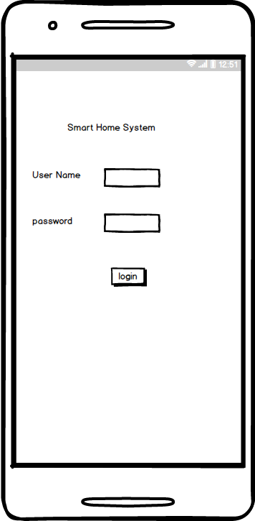

*Figure 1: Log in page of the Smart Home System*

### Choose Device

After the user has been successfully authenticated into the system, he is prevailed with a list of home appliances he is supposed to configure. For example lights, doors, TV, coolers, fans and alarms.

### Control Device

Here the user will be presented with the different options available for configuring a device. For example if the user selected lights, the available options will be to turn on or off.

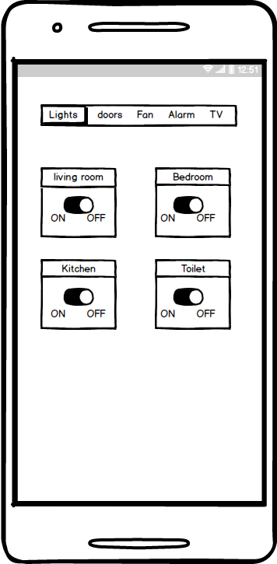

*Figure 2: Interface page for choosing and controlling different lights*

## C:\Users\BRINDA THAKKAR\Desktop\final year project\mock ups\New Mockup 4.png

*Figure 3: Interface page for choosing and controlling different doors*

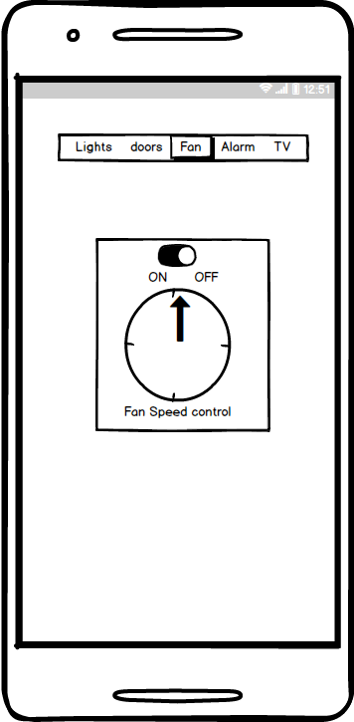

*Figure 4: Interface page for choosing and controlling fans*

## C:\Users\BRINDA THAKKAR\Desktop\final year project\mock ups\New Mockup 7.png

*Figure 5: Interface page for choosing and controlling TV*

## Hardware Interfaces

The system has a mobile application which means that it needs various devices like smart phones and tablets to use the mobile application for interaction with the system.

And the system will have different kinds of sensors like light sensors, temperature sensors, motion sensors.

### Wi-Fi

In order to communicate over long distances without running wires, we came up with a convenient way of communicating with our sensors. The different I/O devices are controlled using TCP/IP over the IEEE 802.11g standard protocol. Data being gathered from sensors, such as temperature sensors, light sensors, and motion sensors is being processed on an Arduino UNO and then broadcast with an attached WI Shield v2.0 to a server using the TCP/IP protocol.

### Arduino UNO

We will use Arduino UNO with a WI Shield v2.0 Wi-Fi 802.11b wireless adapter network card that supports static IP address assignments. The power usage of the Wi-Fi Shield with Arduino is low. It requires 5-7 volts.

## Software Interfaces

The Smart Home System will have a mobile application in order to interact with home appliances and will support only smart phones which use android. As this will help the user to easily choose which device they want to control at any time they want.

The mobile application will be connected to a database in order to capture the user login details.

Software is based on Arduino code that is based on the C programming language. It consists of libraries that create web servers for Arduino UNO and also libraries responsible of setting up software serial communication.

## Communications Interfaces

This application uses Wi-Fi to communicate Android devices and the different. It will also use TCP/IP to send data from the different sensors to the Arduino UNO.

The system will have a login page in order to avoid access to unauthorized users for security of the system.

# System Features

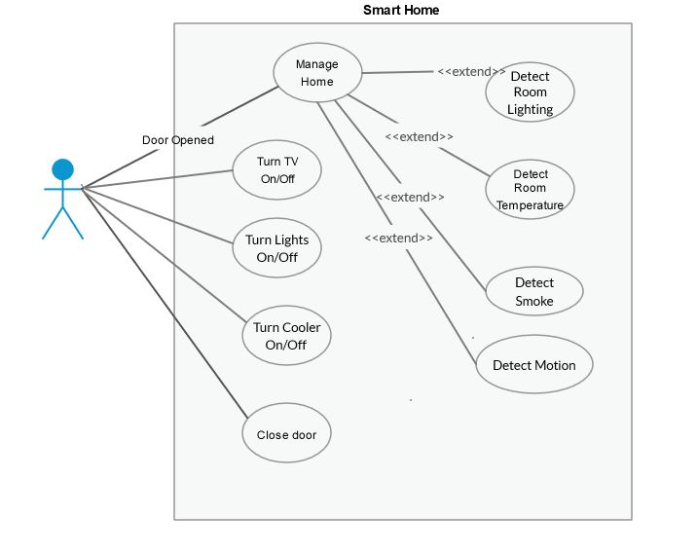

Figure 6: Use case diagram

## Light Control

### Description and priority

It has a light sensor to sense the presence or absence of sunlight for the purpose of controlling lights.

Priority: high

On a scale of 1 to 9, one being low and nine being high this requirement is rated as follows

|  |  |  |  |
| --- | --- | --- | --- |
| Benefit | Penalty | Cost | Risk |
| 9 | 9 | 7 | 5 |

### Stimulus/Response Sequences

|  |  |
| --- | --- |
| User action/ Stimulus | System response |
| When it becomes dark due to no sunlight. | The system turns on the lights. |
| When it becomes bright due to sunlight. | The system turns off the lights. |
| When the user chooses to turn lights on or off from mobile application. | The system turns on or off the lights. |

### Functional Requirements

|  |  |
| --- | --- |
| REQ-1: | The system should sense the light rays from the sun. |
| REQ-2: | The system should turn the lights on or off. |
| REQ-3 | The system should respond to actions from mobile phone. |

## Motion detection

### Description and Priority

This is used to detect the motion of people in and out of a room or home.

Priority: medium

On a scale of 1 to 9, one being low and nine being high this requirement is rated as follows:

|  |  |  |  |
| --- | --- | --- | --- |
| Benefit | Penalty | Cost | Risk |
| 8 | 9 | 7 | 5 |

### Stimulus/Response Sequences

|  |  |
| --- | --- |
| User action | System response |
| Owner enters a room | The system puts on lights if it is dark. |
| Owner walks towards door | Door opens. |

### Functional Requirements

|  |  |
| --- | --- |
| REQ-4: | The system should detect motion of people in home. |

## Temperature control

### Description and Priority

It has a temperature sensor that measures the temperature of the home.

Priority: medium

On a scale of 1 to 9, one being low and nine being high this requirement is rated as follows:

|  |  |  |  |
| --- | --- | --- | --- |
| Benefit | Penalty | Cost | Risk |
| 9 | 9 | 7 | 9 |

### Stimulus/Response Sequences

|  |  |
| --- | --- |
| User action | System response |
| Temperature is high | The system turns on cooler. |
| When temperature is very low | The system turns off cooler. |

### Functional Requirements

|  |  |
| --- | --- |
| REQ-5: | The system should be able to read the room temperature. |

## Alarm

### Description and Priority

It is used to alert the owner in case of any security or safety problem.

Priority: medium

On a scale of 1 to 9, one being low and nine being high this requirement is rated as follows:

|  |  |  |  |
| --- | --- | --- | --- |
| Benefit | Penalty | Cost | Risk |
| 9 | 10 | 4 | 3 |

### Stimulus/Response Sequences

|  |  |
| --- | --- |
| User action | System response |
| User forcefully opens door. | The system sends signal to the alarm |
| Smoke detected in room | The system sends a signal to the alarm |
| User turns off alarm using mobile control. | The system turns off alarm. |

### Functional Requirements

|  |  |
| --- | --- |
| REQ-6: | The system should send a signal to the alarm in case of smoke in a room. |
| REQ-7: | The system should send a signal to the alarm in case of break in. |
| REQ-8: | The system should turnoff alarm when the user chooses to turn it off. |

## Smoke detection

### Description and Priority

It is used to detect smoke in a room/home.

Priority: high.

On a scale of 1 to 9, one being low and nine being high this requirement is rated as follows:

|  |  |  |  |
| --- | --- | --- | --- |
| Benefit | Penalty | Cost | Risk |
| 9 | 10 | 5 | 5 |

### Stimulus/Response Sequences

|  |  |
| --- | --- |
| User action/Stimulus | System response |
| Smoke detected in room | The system sends signal to the alarm |
| User turns off alarm using mobile control. | The system turns off alarm. |

### Functional Requirements

|  |  |
| --- | --- |
| REQ-9: | The system should detect smoke in room. |

## TV controller

### Description and Priority

This feature uses mobile application to control the on and off of television at home.

Priority: medium

On a scale of 1 to 9, one being low and nine being high this requirement is rated as follows:

|  |  |  |  |
| --- | --- | --- | --- |
| Benefit | Penalty | Cost | Risk |
| 7 | 3 | 10 | 2 |

### Stimulus/Response Sequences

|  |  |
| --- | --- |
| User action | System response |
| User selects the on button from the mobile application. | The system should turn on the TV. |
| User selects the off button from the mobile application. | The system should turn off the TV. |

### Functional Requirements

|  |  |
| --- | --- |
| REQ-10: | The system should be able control the Tv using the mobile application. |

## Mobile application

### Description and Priority

It is used to override the other automatic features of the system.

Priority: High

On a scale of 1 to 9, one being low and nine being high this requirement is rated as follows:

|  |  |  |  |
| --- | --- | --- | --- |
| Benefit | Penalty | Cost | Risk |
| 9 | 9 | 9 | 9 |

### Stimulus/Response Sequences

|  |  |
| --- | --- |
| User action | System Action |
|
| User selects to control any feature in system. | The system connects to a network.  The system turns the feature/ device on or off. |

### Functional Requirements

|  |  |
| --- | --- |
| REQ-11: | The system should provide a mobile application control of its features. |

# Other Nonfunctional Requirements

## Performance Requirements

The Smart Home system must perform well and be reliable. Because a Smart Home system integrates devices in the home it is subject to a high number of possible failures like power cuts, power surges etc. The Smart Home system must therefore be able to check and monitor the status of the controlled devices. Also the system must allow users to use these devices even if the automation link between these devices has broken down.

The system shall not add more than two seconds to the time required to perform an  
action if the system is not connected. For example, if it takes 3 seconds to turn the  
Television on normally, it will take no longer than 5 seconds for the Television to  
turn on through the system.

System confirmation of a requested action from the user in the Smart Home System environment shall occur in real time.

## Safety Requirements

In case of power failures or power surges there should be a power backup like inverters, or generators in order to keep the system functioning.

It needs to have constant internet connection for data transfer.

## Security Requirements

There are security risks associated with using the Smart Home System as it is designed to operate on a network like the Internet.When accessing the system the user needs to be assured that intruders, such as hacker attempts and third party invasions, cannot have access to the Smart Home System. The user therefore needs to be confident that the Smart Home System is secure. The ability to authenticate user connections to the system is required.

To prevent unauthorized access the user has to log in to a mobile application in order to have access to the Smart Home System. A secure system to validate the username and password information is required. The system will accept this information as proof of the identity and allow the user to access the Smart Home System.

The Security system shall be able to interface with motion sensor control.

## Software Quality Attributes

### Reliability:

* Mean Time between Failures: The Smart Home System shall not fail on average more than once per week.
* Mean Time to Repair: The Smart Home System shall not take on average longer than two days to repair after a system failure.

### Availability:

* System Availability: The system shall be available 95% of the time unless previously  
  announced for scheduled maintenance or backup.
* Degraded Mode of Operations: In the event of the unavailability of the system, the  
  customers shall see a temporary unavailable screen or response message when requesting the system services.
* System Maintenance Notification: In the event that the system will undergo foreknown system maintenance or data backup, users of the system shall be notified during next interaction with the system.

### Security:

* Customer Confidentiality: The system shall not reveal any personal data in correlation to usage scenarios or statistics.
* Development Access: All development work shall be password protected at or above the rigor of the Iowa State Computer Science password standards.

### Maintainability:

* System Reset: The system shall provide the ability to reset all settings to the default or a saved configuration.
* Developer Access: The system administrator shall be able to grant developer privileges to users.
* Code Maintainability: The programming code developed for the Smart Home System shall conform to programming style standards and shall be commented thoroughly as determined by a code review team.

## Business Rules

1. The user cannot control more than one appliance at the same time i.e. controlling lights and doors at the same time.
2. When there is no internet connection, the user cannot override the system functionality via the mobile application.
3. The user can only override system functionality when he has logged into the system through the mobile application with an authenticated username and password.

# Other Requirements

## Appendix A: Glossary

|  |  |
| --- | --- |
| Terms | Explanation |
| User | Someone who interacts with the system |
| Administrator | Someone who does the system configurations and installation. And also troubleshooting. |
| SRS | Software Requirements Specification |
| REQ | Requirement |
| Arduino UNO | A micro-controller |
| I/O | Input and output devices |
| TCP/IP | Transfer control protocol/ Internet protocol |
| IEEE | Institute of Electrical and Electronics Engineering |
| Wi-Fi | Wireless fidelity |
| WI Shield | Wireless shield |
| IR | Infrared |